

**Tobor Inc.**

App Automation: Register, Deliver and Report

Detailed Process Description

Version 1.01

Revision History

|  |  |  |  |
| --- | --- | --- | --- |
| Date Issued | Version | Description | Author |
| *16.06.2020* | *1.0* | *Initialize* | *James Harper* |
| *17.06.2020* | *1.01* | *Updates* | *James Harper* |
|  |  |  | *Name* |

Contributors

The content of this document has been authored with the combined input of the following group of key individuals.

|  |  |  |
| --- | --- | --- |
| Name | Role | Area |
| *James Harper* | *RPA Developer* | *Consulting* |

Business Sign-off

The following table contains the people required to sign-off and/or review this document and those that require the document for information only.

|  |  |  |
| --- | --- | --- |
| Name | Department | Responsibility |
| *David Bradbury* | *Management Director* | *Review* |
| *Roberto Fernandez* | *Backend Application Manager* | *Information* |
| *Chris Lucas* | *Consultant Project Liaison* | *Sign Off* |

Document Classification

|  |  |
| --- | --- |
| Classification | *e.g. Company Confidential* |
| Definition | *e.g. Information is company confidential and needs to be protected* |
| Context | *e.g. Where loss of information confidentiality would result in significant harm to the interests of the Organisation, financial loss, embarrassment or loss of information* |
|  |  |

Contents

1 Introduction 4

2 Manual Process 4

2.1 Overview 4

2.2 Detailed Process Flow 4

3 Automation Proposal 4

3.1 Overview 4

3.2 Automated Process Flow 4

3.3 Target Systems & User Requirements 4

3.4 Impacted Business Areas 5

3.5 Workload 5

3.6 Operational Constraints 5

3.7 Delivery 5

3.8 Contact List 5

4 Automation Details 6

4.1 Automation Walkthrough 6

4.1.1 *First robot action* 6

4.1.2 *second robot action* 6

4.1.3 *third robot action etc.* 6

4.2 Reporting 6

4.2.1 Business Exceptions 6

4.2.2 System Exceptions 6

4.2.3 Performance 7

4.2.4 Triggers 8

# 1 Introduction

*Tobor Inc. has requested consultation with their app automation. This process involves taking in registering details from a customer to create a presence on their software.*

*This then goes onto expand with taking in data from a selection of websites that the user selects via a pre-defined list of hobbies, e.g. sports and hobbies. Then the automation goes onto tidy up the data and send it to the user.*

*Lastly, the user options they requested are tallied down and noted as means of data collection for Tobor Inc. to help with further development.*

# 2 Manual Process

## 2.1 Overview

* *User sends their registration details to the company email. Details being the user’s first name, last name, phone number, address, email address, the content they request and the frequency it gets delivered.*
* *Details are then stored by the company, usually locally, with the option of changing/removing them.*
* *Content is taken from three different website options (Sport, Tech, Hobbies) daily. Content being described as a brief description of what’s going on.*
* *A report is taken before the content is sent off, noting who will receive that aggregated data and what the day is.*
* *These reports are then compiled together into a larger report of what was sent out on that day. This is stored locally on a company computer.*

## 2.2 Detailed Process Flow

Registration: Content Delivery:

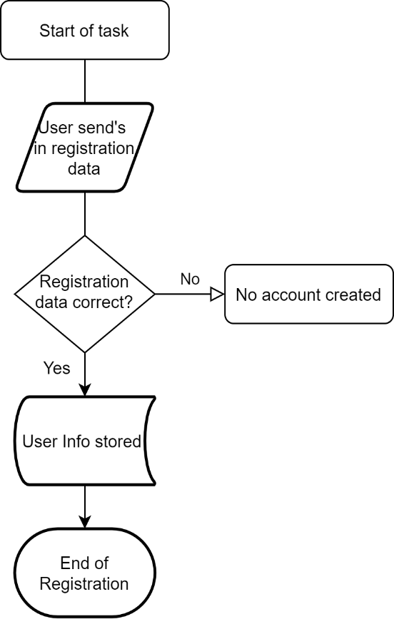 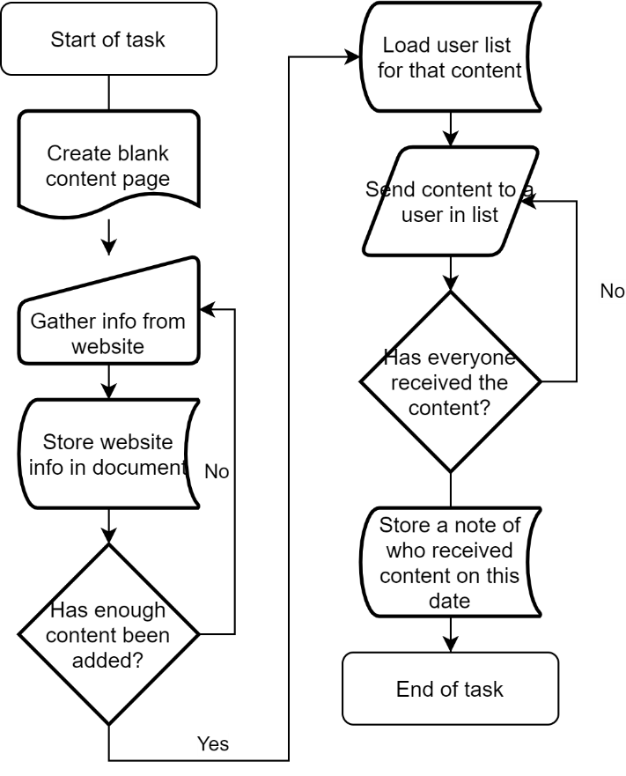

Report Collation:

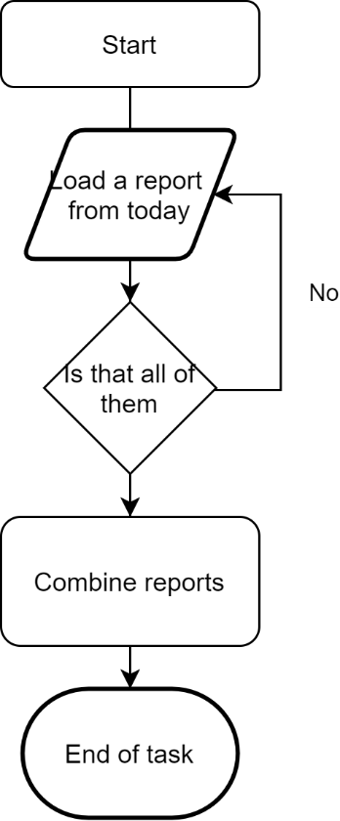

# 3 Automation Proposal

## 3.1 Overview

*The automation proposed would take care of the registering, content aggregation, report filing and content delivery. There is to be an overarching automation aspect that happens at half eleven in the morning triggering all the processes contained. If any submissions are to be made after this deadline, they will need ot be held until the next day.*

*Registering would occur via the user sending their details, as described in the manual process, to the company email. In this case we’re using the QA academy trainee e-mail to simulate that as accessing a company email isn’t possible. The Automation involved will then log these details down and send them to the UIPath Orchestrator as an individual object with its own unique identifier. If any of these users send an incomplete dataset, or there are other problems an email will be sent back to the user stating as such, while also logging a fatal error with UIPath. A follow up e-mail can then be sent at the user’s discretion if they want their detail altered or removed with sending a subject of ‘CHANGE’ or ‘DELETE’.*

*The second automation proposes that select websites be used for the content aggregation. For this, each hobby will have a list of websites it needs to access for it’s data set. Every day the automation will go to the websites given and collect snippets of data, a title and first paragraph for example, depending on the website. The automation will then take the snippets and format it to look more presentable to the user, then send the final product in an email. Once sent a local report will be generated to say who this was sent to, and on what date. This will then be repeated for every hobby class for that day.*

*Lastly, the content reports are collected for that day, collated together and sent to the company email, or the QA email in this case. These are marked with how many people ordered that topic for that day.*

## 3.2 Automated Process Flow

*If the automation process flow adheres to the manual process flow above, there is little need to duplicate. A statement to that effect should suffice, confirming all actions will be automated. Otherwise, a detailed flow should be presented.*

*Main Process:*

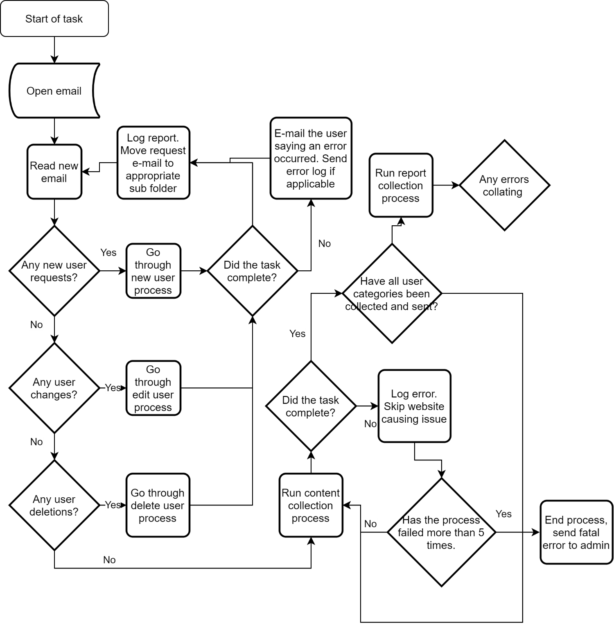

## 3.3 Target Systems & User Requirements

| Name | Description | User Permissions/Access |
| --- | --- | --- |
| *e..g. MS Outlook* | *e.g. Email Inbox* | *e.g. Robot Inbox required e.g.* [*robot1@xyz.com*](mailto:robot1@xyz.com)*, access to* [*LoginRequest@xyz.com*](mailto:LoginRequest@xyz.com)*,*[*Customer.care@xyz.com*](mailto:Customer.care@xyz.com) |
| *e.g. CRM* | *e.g. Customer Relationship Management system used for Billing* | *e.g. Admin* |
|  |  |  |

## 3.4 Impacted Business Areas

* *Department / Areas affected by the automation*

## 3.5 Workload

*Metrics related to the automation, table example below*

|  |  |
| --- | --- |
| *Max. no. of Login Requests per week* | *70* |
| *Min. no. of Login Requests per week* | *10* |
| *Average no. of Login Requests per week* | *50* |
| *Are there any periods when a higher workload is anticipated?* | *August* |
| *How many people do this process per day?* | *1* |

***Summary of average time process takes a user to run manually, include timings of any dependant parts such as responses coming back from 3rd parties.***

***Automating the steps below will realise an average time saving of X minutes (X hrs) per day for <Process Name>:***

* *List of manual steps with manual execution time (Breakdown of all time saved)*

*Acronyms – detail the meanings of any acronyms used above e.g. systems, clients etc.*

## 3.6 Operational Constraints

* *List of all operational constraints. Examples could be working hours, system availability etc. – essentially anything that could have a bearing on how the automation can function.*

## 3.7 Delivery

*The time scale for the development, testing and delivery of this project. In the early stages this may indicate the timescale is to be finalised.*

## 3.8 Contact List

*List of key contacts for the project, both QA Ltd and Client e.g.*

*RPA Programme Sponsor – Gillian Lomax*

*Head of Operations – Harry Grainger*

*RPA Project Manager – Carrie Smith*

*RPA Consultant – Chester Gardner*

*Department SMEs – Marianne Spencer (Customer Onboarding), Jane Baker (Process Development)*

# 4 Automation Details

## 4.1 Automation Walkthrough

### 4.1.1 *First robot action*

* *Description of first Robot step to complete action, include screenshots where necessary*
* *Description of second Robot step to complete action, include screenshots where necessary*
* *Etc.*

### 4.1.2 *second robot action*

* *Description of first Robot step to complete action, include screenshots where necessary*
* *Description of second Robot step to complete action, include screenshots where necessary*
* *Etc.*

### 4.1.3 *third robot action etc.*

* *Continue as required to complete all Robot actions within the automation*

## 4.2 Reporting

### 4.2.1 Business Exceptions

|  |  |
| --- | --- |
| Exception | Solution |
| *List of expected or assumed exceptions* | *Details of method of handling exception* |
|  |  |
|  |  |
|  |  |
|  |  |
|  |  |

### 4.2.2 System Exceptions

|  |  |
| --- | --- |
| Exception | Solution |
| *List of expected or assumed exceptions* | *Details of method of handling exception* |

A performance report will be emailed to *<Client Contact>* each time the process runs (showing worked cases, exceptions and a cumulative processing log)

### 4.2.3 Performance

Once the processes have successfully completed a performance report and processing log will be emailed to *<Client Contact>* as an excel file.

**Performance Report**

This will contain all exceptions (business and system) and successes for the automated Process, based on the last automation execution completion (i.e. based on the last time the process ran)

EXAMPLE REPORT

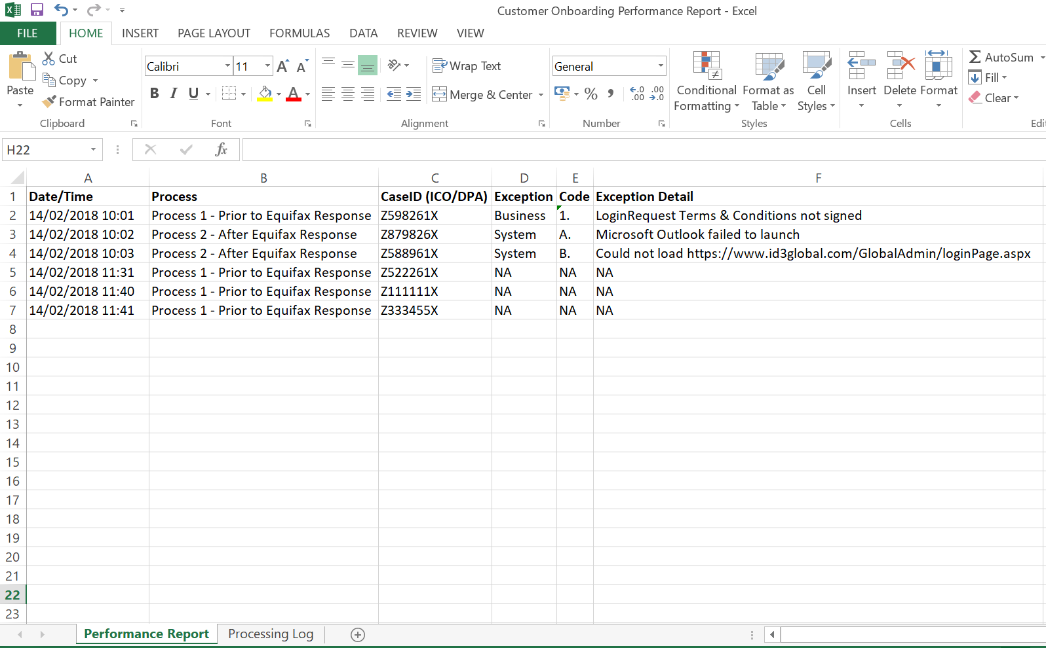

www.xip.com/Admin/loginPage.aspx

CredBest

CredBest

CredBest

CredBest

CredBest

CredBest

**Processing Log**

This will show cumulative successes from the automated Process:

EXAMPLE REPORT

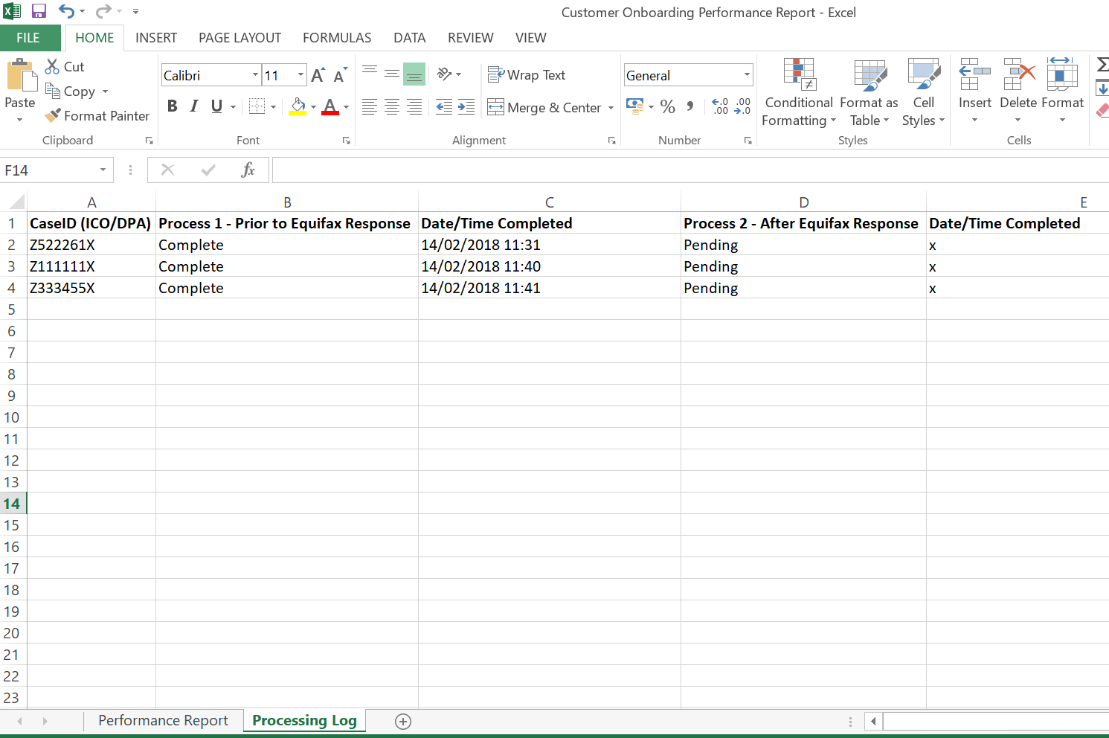

**CredBest**

**CredBest**

### 4.2.4 Triggers

*Definition of how the Robot will be triggered. This could simply define that this is a manual trigger i.e. an attended start, or could indicate more advanced triggers such as on a particular event or schedule.*

**UPDATE THE TABLE OF CONTENTS AND ENSURE ALL RED TEXT HAS BEEN UPDATED/REMOVED PRIOR TO DISTRIBUTION**